Create an ARIMA Model for time series forecasting
EX:No.8 DATE:12/04/25

AIM:
To Create an ARIMA Model for time series forecasting.

ALGORITHM:
- ADF Test – Checks if the PM2.5 time series is stationary using statistical significance.
- Differencing – Transforms non-stationary data to stationary by subtracting consecutive values.
- ARIMA Model Selection – Chooses ARIMA(p,d,q) model where p = autoregressive lags, d = differencing, q = moving average lags.
- Model Training – Fits the ARIMA model to historical PM2.5 data using specified parameters.
- Forecasting – Predicts future PM2.5 values for the next 30 days using the trained model.
- Visualization – Plots actual vs forecasted PM2.5 levels to visualize model performance.

Code:
import pandas as pd
import matplotlib.pyplot as plt
from statsmodels.tsa.arima.model import ARIMA
from pandas.plotting import register_matplotlib_converters
from statsmodels.tsa.stattools import adfuller
import seaborn as sns
register_matplotlib_converters()
# Step 1: Load the dataset
df = pd.read_csv('/content/MSFT.csv', parse_dates=['Date'])
df.set_index('Date', inplace=True)
# Step 2: Handle encoding issues
# Print the available columns to check for the correct name
print(df.columns)
df.columns = [col.encode('utf-8').decode('utf-8').replace("Â", "") for col in df.columns]
df = df.apply(pd.to_numeric, errors='coerce') # convert all to numeric, force errors to NaN
# Step 3: Drop missing values
df = df.dropna()

# Use the correct column name identified from the print statement
plt.figure(figsize=(10, 4))
# Replace 'PM2.5 (µg/m³)' with the actual column name from your CSV file
plt.plot(df['Close'], label='PM2.5')
plt.title('PM2.5 over time')
plt.legend()
plt.show()
# Step 5: Check stationarity using ADF test
# Replace 'PM2.5 (µg/m³)' with the actual column name
result = adfuller(df['Close'])
print('ADF Statistic:', result[0])
print('p-value:', result[1])
# Step 6: Differencing (if p-value > 0.05)
# Replace 'PM2.5 (µg/m³)' with the actual column name
df['PM2.5_diff'] = df['Close'].diff().dropna()
# Step 7: Fit ARIMA model (you can tune p,d,q manually or use auto_arima)
# Replace 'PM2.5 (µg/m³)' with the actual column name
model = ARIMA(df['Close'], order=(1,1,1)) # Example (p=1, d=1, q=1)
model_fit = model.fit()
# Step 8: Summary
print(model_fit.summary())
# Step 9: Forecast
forecast = model_fit.forecast(steps=30) # Forecasting next 30 time points
# Step 10: Plot forecast
plt.figure(figsize=(10, 4))
# Replace 'PM2.5 (µg/m³)' with the actual column name
plt.plot(df['Close'], label='Historical')
plt.plot(pd.date_range(start=df.index[-1], periods=31, freq='D')[1:], forecast, label='Forecast', color='red')
plt.legend()
plt.title('PM2.5 Forecast')
plt.show()

OUTPUT:
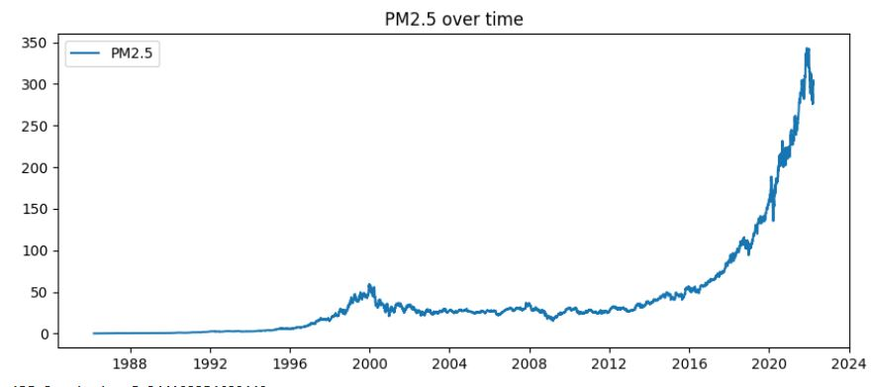
ADF Statistic: 5.344103354680442
p-value: 1.0
/usr/local/lib/python3.11/dist-packages/statsmodels/tsa/base/tsa_model.py:471: ValueWarning: A date index has been provided, but it has no associated frequency information and so will be ignored when e.g. forecasting.
self._init_dates(dates, freq)
/usr/local/lib/python3.11/dist-packages/statsmodels/tsa/base/tsa_model.py:471: ValueWarning: A date index has been provided, but it has no associated frequency information and so will be ignored when e.g. forecasting.
self._init_dates(dates, freq)
/usr/local/lib/python3.11/dist-packages/statsmodels/tsa/base/tsa_model.py:471: ValueWarning: A date index has been provided, but it has no associated frequency information and so will be ignored when e.g. forecasting.
self._init_dates(dates, freq)
SARIMAX Results
==============================================================================
Dep. Variable: Close No. Observations: 9083
Model: ARIMA(1, 1, 1) Log Likelihood -15043.860
Date: Sat, 12 Apr 2025 AIC 30093.721
Time: 07:28:57 BIC 30115.063
Sample: 0 HQIC 30100.979
- 9083
Covariance Type: opg
==============================================================================
coef std err z P>|z| [0.025 0.975]
------------------------------------------------------------------------------
ar.L1 -0.3316 0.015 -22.436 0.000 -0.361 -0.303
ma.L1 0.1709 0.016 10.963 0.000 0.140 0.201
sigma2 1.6080 0.005 299.855 0.000 1.598 1.619
===================================================================================
Ljung-Box (L1) (Q): 0.00 Jarque-Bera (JB): 657344.01
Prob(Q): 1.00 Prob(JB): 0.00
Heteroskedasticity (H): 303.96 Skew: -0.37
Prob(H) (two-sided): 0.00 Kurtosis: 44.67
==================================================================================

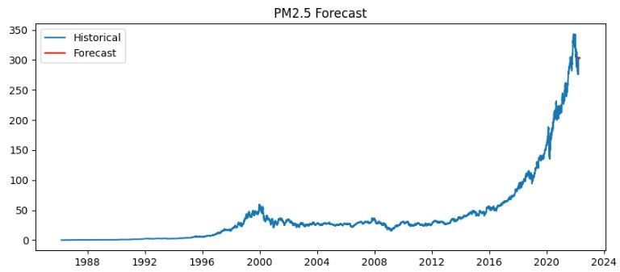

RESULT:
Thus, the program using the time series data implementation has been done successfully.

